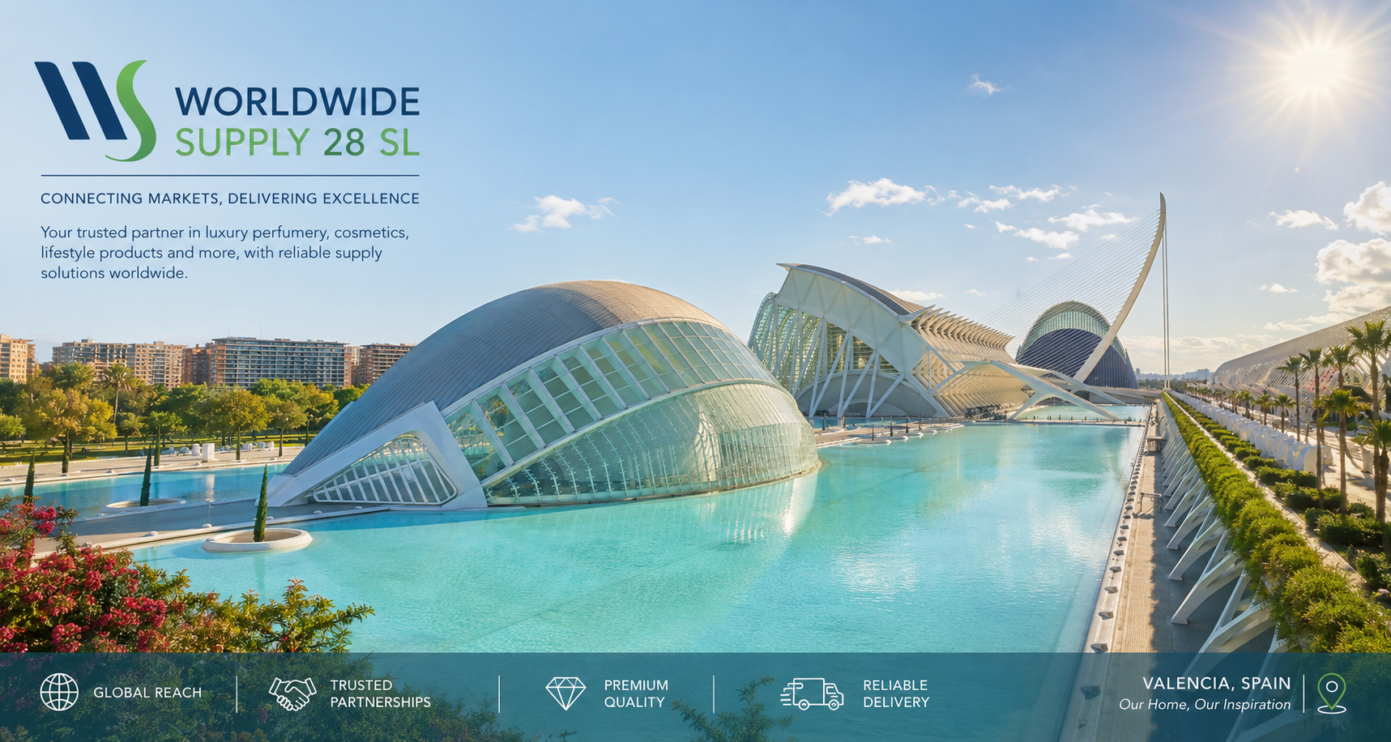VALENCIA, SPAIN
Our Home, Our Inspiration
WORLDWIDE SUPPLY 28 SL
Website Content & Company Information Package
Prepared for the website development team, in response to the Website Requirement Document. This document contains company information, brand direction, and content to be used for the new corporate website.

1. Business Information

Business Overview
Worldwide Supply 28 SL, based in Spain, has over 15 years of experience in wholesale, luxury retail, and travel retail. We work with leading international retailers, duty frees, and distributors worldwide, supplying high-end perfumery, luxury cosmetics, skincare, and niche fragrances. We represent products from major groups such as LVMH, PUIG, L’Oréal Luxe, and COTY, P&G etc … as well as selected niche perfume houses, and we are ready to provide reliable, large-scale supply to support our clients’ business globally. Our team is committed to flexible and consistent delivery to meet the needs of clients in multiple markets.

Company History – Our Story
Worldwide Supply 28 SL was born from the shared vision of two partners whose paths in the luxury and wholesale industry were destined to meet.
Siddharth Thakker grew up surrounded by the world of duty-free and wholesale trade, as part of a family business with deep roots in the wholesale and retail distribution sector. From an early age, he learned the value of strong supplier relationships, market instinct, and the discipline required to move goods reliably across borders.
Sakina Idmouhine built her career within the perfumery and luxury cosmetics industry, spending over 15 years mastering the details that make this sector unique, from brand relationships to the expectations of international retailers and distributors.
When their paths crossed, they quickly recognized that their backgrounds were not just compatible, but complementary: one side brought deep-rooted trade and logistics experience, the other brought sector-specific expertise and a strong network within the perfumery and cosmetics world. United by a shared passion for the industry and a mutual belief in doing business the right way with reliability, transparency, and long-term relationships, they founded Worldwide Supply 28 SL.
More than business partners, Sakina and Siddharth work together like family, sharing the same drive, ambition, and hunger to keep growing. That spirit of togetherness and continuous growth is what defines Worldwide Supply 28 SL today, and what motivates the team to keep building stronger relationships with brands, retailers, and distributors around the world.

Mission & Vision
Mission: To connect global brands with trusted retail, duty-free, and distribution partners worldwide, delivering premium perfumery, cosmetics, and lifestyle products with reliability, flexibility, and consistency at every stage of the supply chain.
Vision: To become a leading international gateway for brands seeking to enter new markets, and for retailers and distributors seeking a dependable long-term sourcing partner in the luxury and premium goods sector.

Core Values
- Reliability – consistent, dependable delivery for every client, every time
- Transparency – honest, long-term relationships with partners and clients
- Flexibility – adapting to the needs of each market and client profile
- Growth mindset – a continuous drive to expand, improve, and innovate
- Family spirit – a close-knit team culture built on trust and shared ambition

Company Profile (PDF/Brochure)
To be provided, a downloadable company brochure/profile PDF can be prepared separately once final branding assets are ready.

2. Branding

Logo & Brand Colors
Logo colors: Blue, Green, White. The logo file will be shared separately by email.
Background imagery: We would like the website to feature a high-quality, sunny Valencia, Spain background image, with particular emphasis on the City of Arts and Sciences. The image should communicate Valencia's light, warmth, Mediterranean character, and international identity, while remaining elegant and premium. The visual treatment should work harmoniously with the company palette of blue, green, and white and should leave sufficient clean space for website text and calls to action.

Website Style Direction
We would like the website to reflect a modern, minimalist, and luxurious aesthetic, in line with current European design trends for premium and wholesale brands in the perfumery and cosmetics sector textile drinks etc... Key style guidelines:
- Overall feel: Clean, sophisticated, spacious layouts with generous white space, conveying trust and premium quality
- Color palette: Based on our logo tones (blue, green, white) used as accents, combined with neutral tones (white, soft grey, black) for a refined, high-end feel
- Typography: Elegant, modern sans-serif fonts (or a refined serif for headings)
- Imagery: High-quality, editorial-style photography rather than generic stock photos
- Layout: Minimalist grid-based structure, smooth transitions, mobile-first responsive design
- Reference feel: Understated elegance, similar to premium European B2B / luxury brand websites

3. Website Objective
- Company Profile Website
- International Business Presence
- Generate Business Inquiries
- Build Trust & Credibility
- Showcase Wholesale & Distribution Capabilities

4. Website Pages
Proposed pages (please confirm):
- Home
- About Us
- Product Categories
- Services
- Why Choose Us
- Contact Us
- Privacy Policy
- Terms & Conditions

5. Product Categories
- Perfumes & Fragrances
- Niche Fragrances
- Luxury Cosmetics & Skincare
- Wines & Spirits
- Textiles
- Accessories
- Jewelry
- Travel Sets
Note: Only categories will be displayed on the website. No individual products or brand listings.

6. Services

Global Distribution
We supply premium perfumery, cosmetics, wines & spirits, and lifestyle products to retailers, duty-free operators, and distributors across international markets. With a strong presence in wholesale and travel retail, we act as a reliable bridge between manufacturers and buyers worldwide, ensuring products reach the right markets efficiently. Our global network allows us to serve clients across multiple continents simultaneously, adapting to the specific needs of each market and client profile.

Logistics Management
Backed by more than 15 years of experience and a strong network of freight forwarders, we manage the full logistics process from origin to destination. We coordinate international shipping, customs documentation, and delivery scheduling to ensure goods arrive on time and in optimal condition. Our logistics expertise allows us to offer flexible and consistent delivery solutions, regardless of order volume or destination.

Brand Introduction & Market Entry
We help brands looking to expand internationally by introducing them to new markets and connecting them with the right retail and distribution partners. Leveraging our established relationships across the luxury and premium goods sector, we support brands in building visibility and credibility in markets where they are not yet present. This service is ideal for companies seeking a trusted local partner to accelerate their global growth.

Sourcing & Supplier Development
We are continuously expanding our network of suppliers and product categories to better serve our clients’ evolving needs. We actively seek new partnerships with manufacturers and brand owners to diversify our offering and provide clients with a wider, more competitive product range. This ongoing sourcing effort ensures our catalogue stays relevant to market trends and client demand.

7. Company Highlights
Years of Experience: 15+ years
Countries Served: Global reach across Europe, Asia, the GCC, Africa, and the USA
Business Presence: Spain-based, serving wholesale, luxury retail, and travel retail clients worldwide
Distribution Network: Established network of international freight forwarders ensuring reliable global delivery
Key Strengths: Strong relationships with major groups (LVMH, PUIG, L'Oréal Luxe, COTY) and selected niche houses; broad and growing product portfolio
Certifications: Registered company in Spain – Tax ID (CIF): B26703769. Company registration certificate available upon request.

Why Choose Us
- 15+ years of experience in wholesale, luxury retail, and travel retail
- Strong relationships with major groups such as LVMH, PUIG, L'Oréal Luxe, and COTY
- Established international network of freight forwarders for reliable global delivery
- Flexible, consistent supply adapted to each market's needs
- Wide and growing product range: perfumery, cosmetics, wines & spirits, jewelry, accessories, and more
- Trusted partner for brands seeking market entry and international expansion

8. Media Assets
The following assets will be sent separately and re-search by your team
:
- Logo (blue / green / white)
- Warehouse images (in google or AI)
Valencia background image: City of Arts and Sciences, sunny and elegant, using blue, green and white tones.
- Team photos (google or AI) Siddharth and I pictures we will send later on so you can add to the website once it’s done.
- Logistics images (google AI)
- Category images (google AI)

9. Contact Information
Address: Calle Carlos Cervera, 14, Bajo, 46006, Valencia, Spain
Phone / Mobile: +34 614 85 05 70
WhatsApp: +34 614 85 05 70 – Available 24/7
Email: info@worldwidesupply28.com
Website: www.worldwidesupply28.com
Google Map Location: To be provided based on office address
Business Hours: Office hours: Monday – Friday, 9:00 – 17:00 (CET). WhatsApp support available 24/7.

10. Contact Form
Required fields:
- Name
- Company Name
- Country
- Email
- Phone Number
- Message

11. Website Features
- Responsive Design
- Contact Form
- WhatsApp Chat
- Google Maps
- Social Media Links
- Download Company Profile (optional)
- Multi-language Support: English and Spanish (preferred)

12. Legal Pages
- Privacy Policy – to be drafted based on data use
- Terms & Conditions – pending legal advisory review
- Cookie Policy – if required

13. Technical Details
Domain Name: www.worldwidesupply28.com
Hosting Details: To be confirmed
Business Email: info@worldwidesupply28.com
SSL Certificate: To be included
Worldwide Supply 28 SL – Valencia, Spain – info@worldwidesupply28.com – www.worldwidesupply28.com

